|  |  |
| --- | --- |
|  | **FPT ACADEMY INTERNATIONAL**  **FPT – APTECH COMPUTER EDUCATION** |

**Centre Name: ACE-HCMC-FPT.**

**Address: 590 Cach Mang Thang 8, District 3, Ho Chi Minh City, Viet Nam.**

**Insurance online**

**Installation Guide**

|  |  |  |
| --- | --- | --- |
| **Supervisor:** | Mr. Hoang Duc Quang | |
| **Semester:** | 3 | |
| **Batch No:** | T1.2011.M0 | |
| **Group No:** | 3 | |
| **Team member:** | **Full name** | **Roll No.** |
| 1. | Do Tran Long | Student1287966 |
| 2. | Do Thanh Nam | Student1286087 |
| 3. | Le Ngan Tam | Student1288146 |
| 4. | Dinh Ngoc Minh Hieu | Student1285592 |

**Month: May Year:** 2022

1. **Software and Hardware Requirement**
2. **Hardware requirement**

|  |  |
| --- | --- |
| **Component** | **Requirement** |
| **Server** | Processor type:  Pentium IV-compatible processor or faster.  Processor speed:  Recommended: 2.0 GHz or faster |
| **OS** | Microsoft Windows Server 2003 or higher |
| **Memory (RAM)** | Minimum: 1 GB  Recommended: 4 GB or more  Maximum: Operating system maximum |
| **Hard Drive** | Free space:  Minimum: 200 MB  Recommended: 50 GB or more  Maximum: Operating system maximum |

1. **Software requirement**

|  |  |
| --- | --- |
| **Component** | **Requirement** |
| **Microsoft .NET Framework** | Version 4.5.x |
| **Microsoft Visual Studio** | Microsoft Visual Studio 2022 |
| **RDBMS** | SQL Server 15.0.18206.0 |
| **Hosting** | IIS 8.0 or higher |
| **Web Browser** | Chrome (recommended), Firefox, IE 7 or higher |

1. **Configuration**
2. **Database Configuration**

1.1 Open Microsoft SQL Server Management Studio 18 and connect to server:

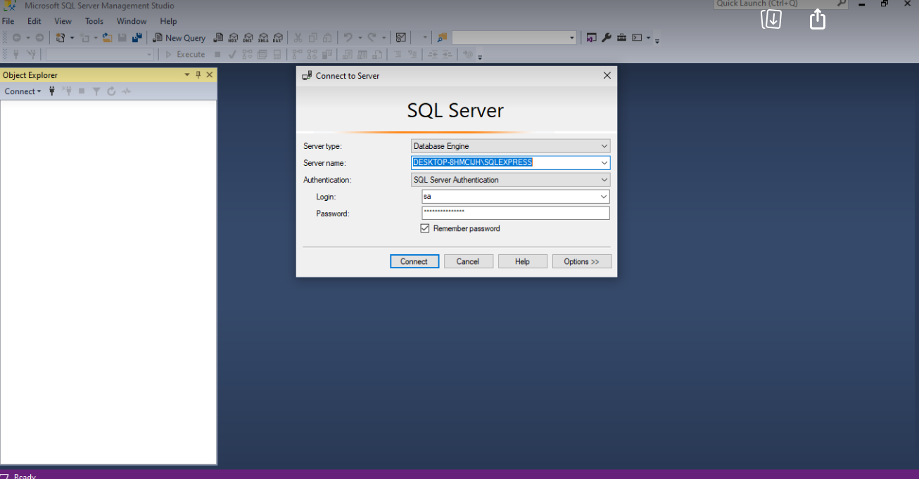

+Open Insuranceonline -->Document-> 123.bak and copy 123.bak-> paste Window C:

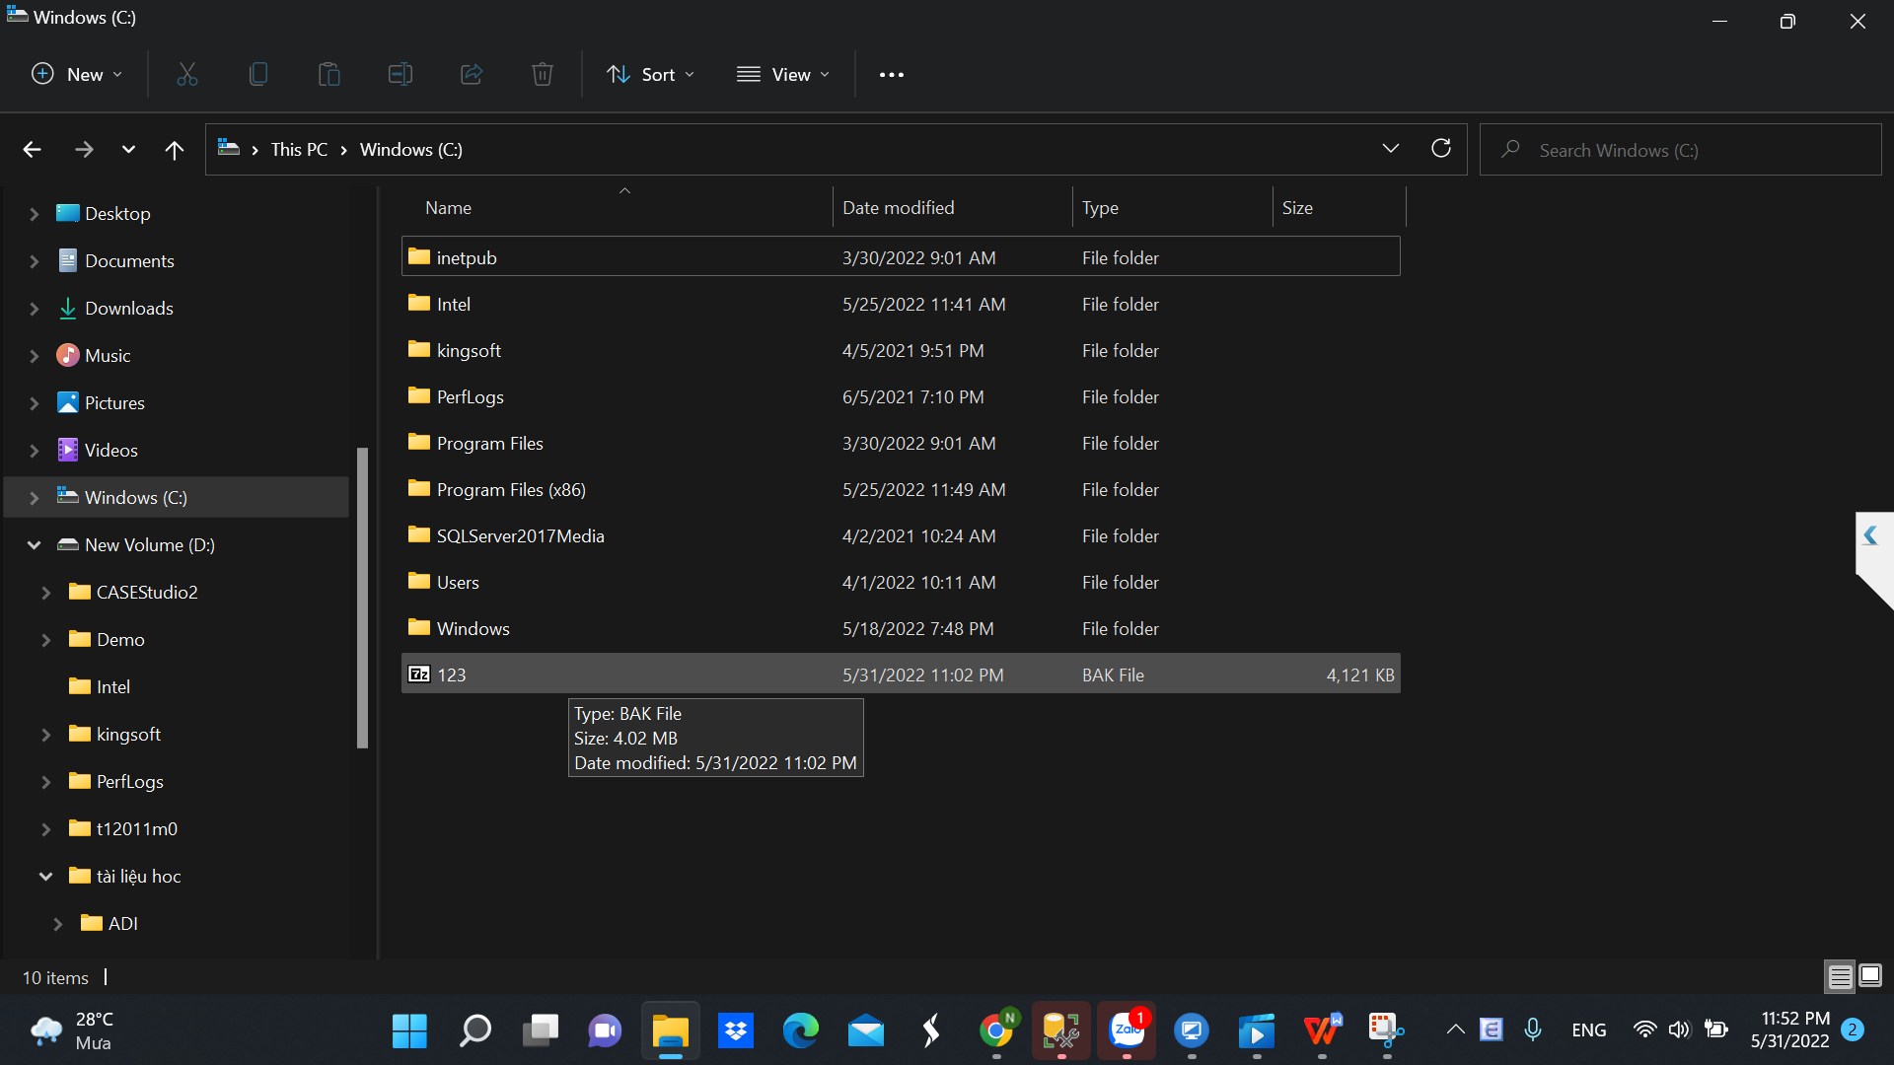

1.2 Open the attached Microsoft SQL Server Management Studio 18 :

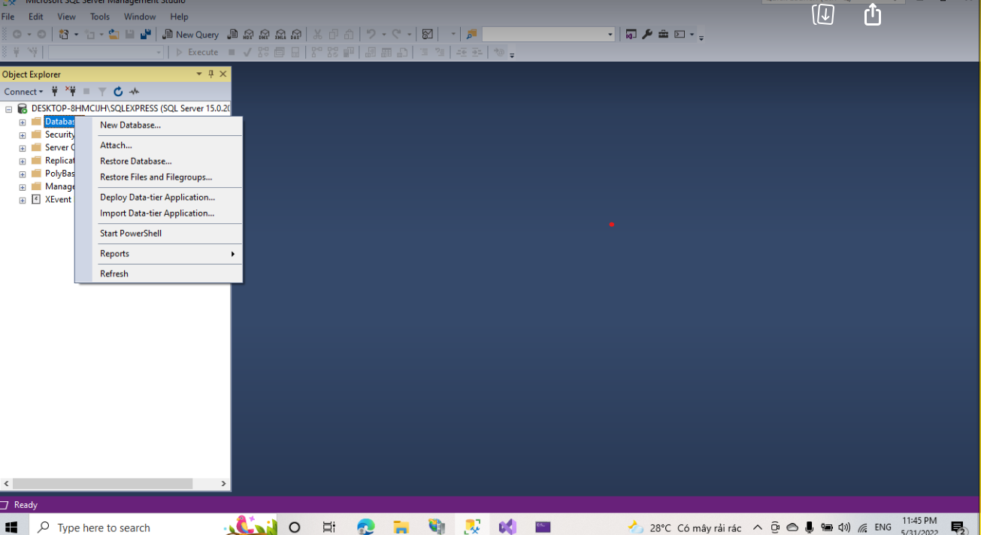

+Choose Restore Database

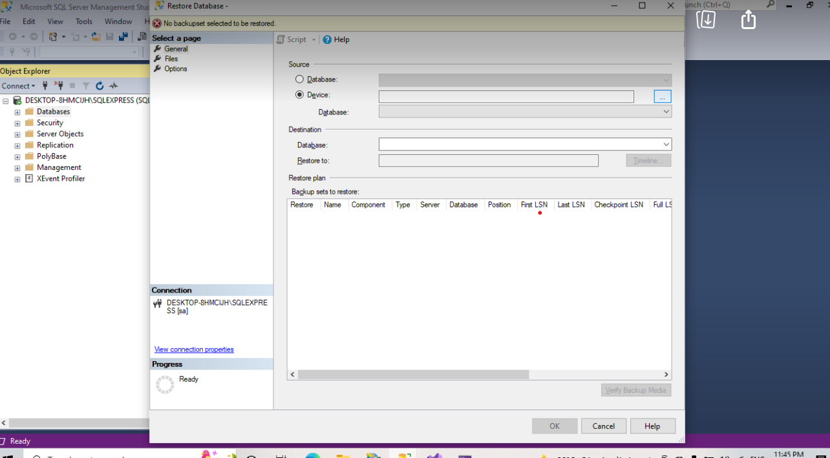

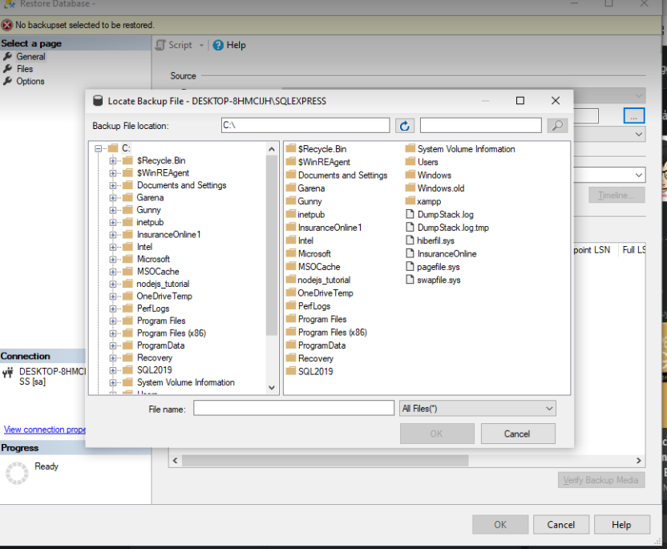

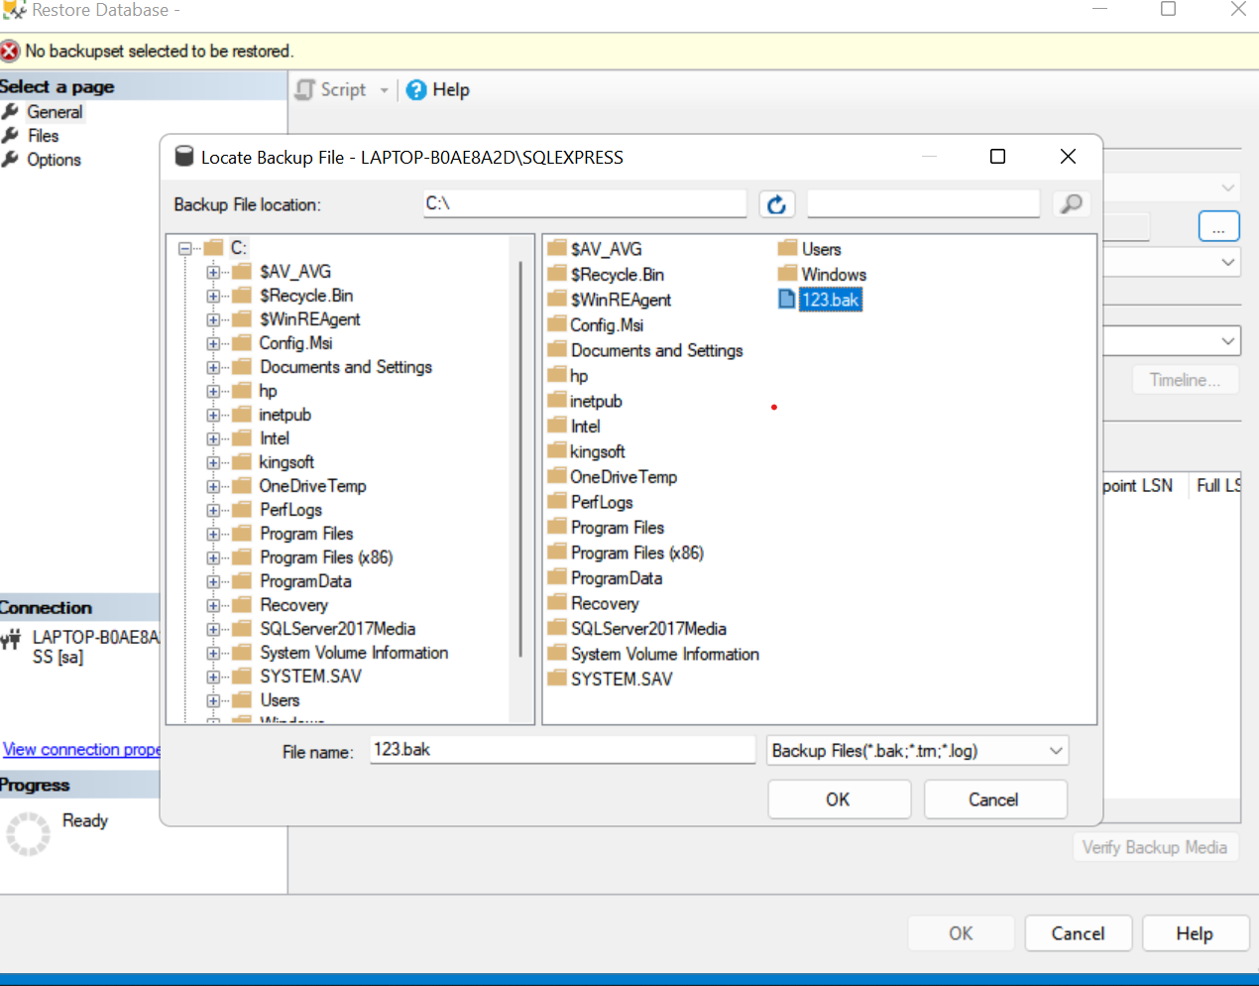

+ After OK -> OK

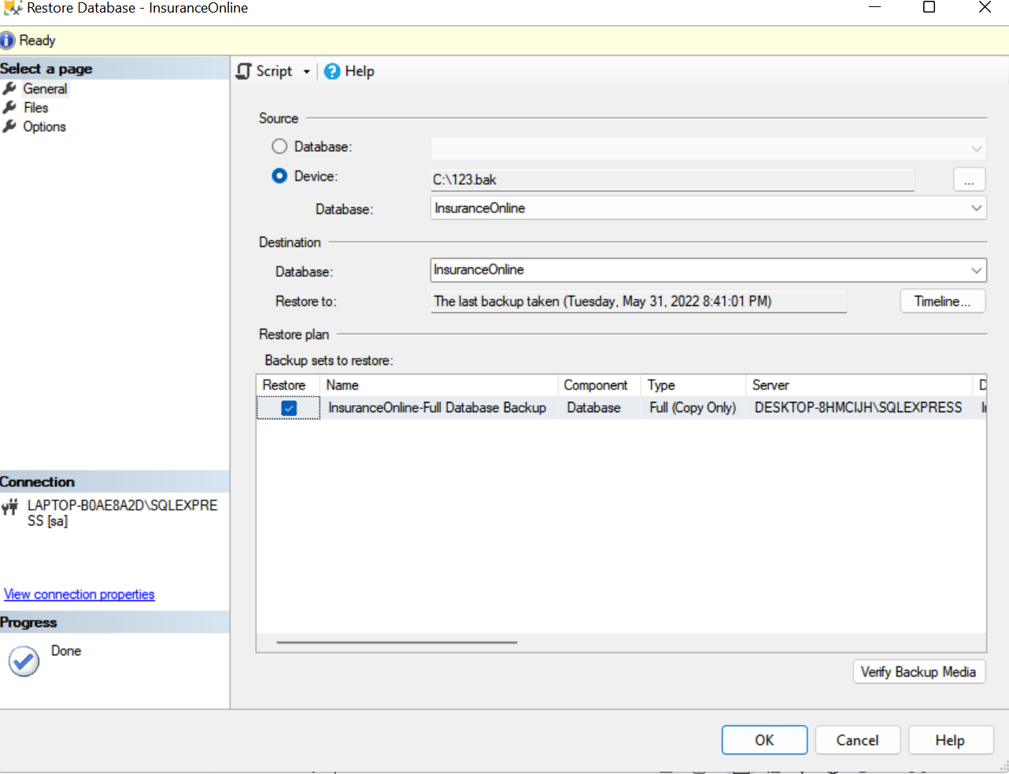

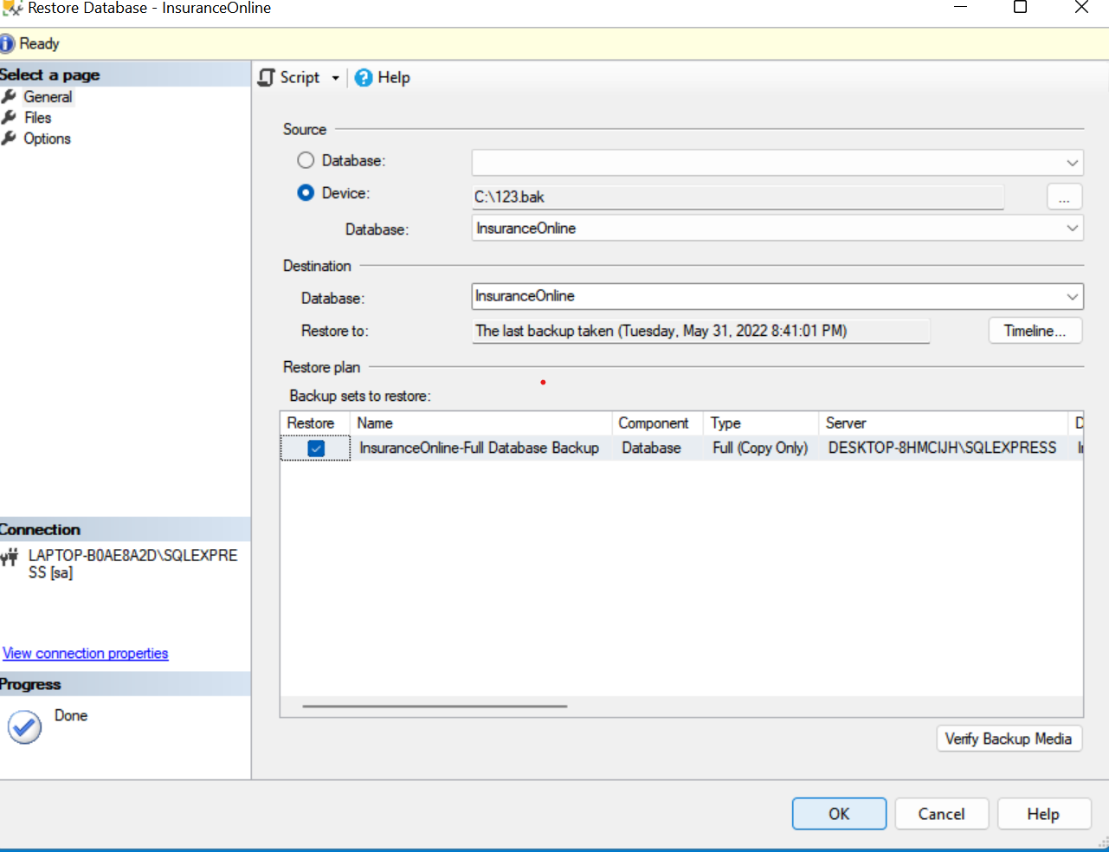

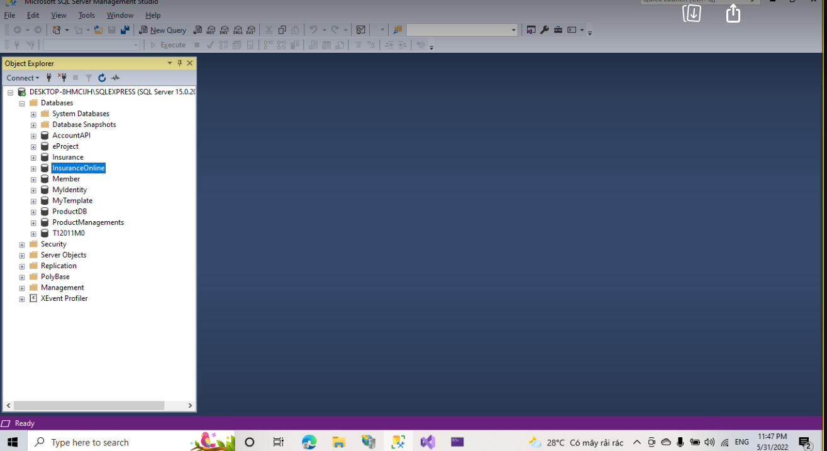

1. **Open Project**

2.1 Open Visual Microsoft Visual Studio 2022 and Download packages as follows:

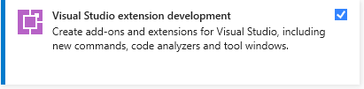

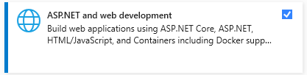

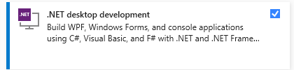

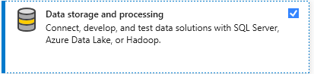

2.2 Locate ***WebApp*** solution file in Source Code / eProject folder.

+ Double-click on ***WepApp.sln*** to open project in Microsoft Visual Studio 2022

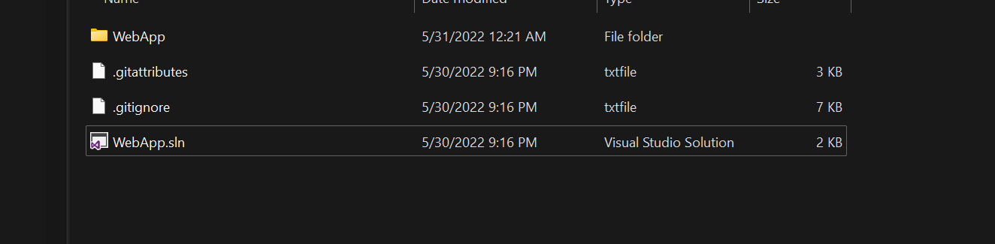

+ Fix connection:

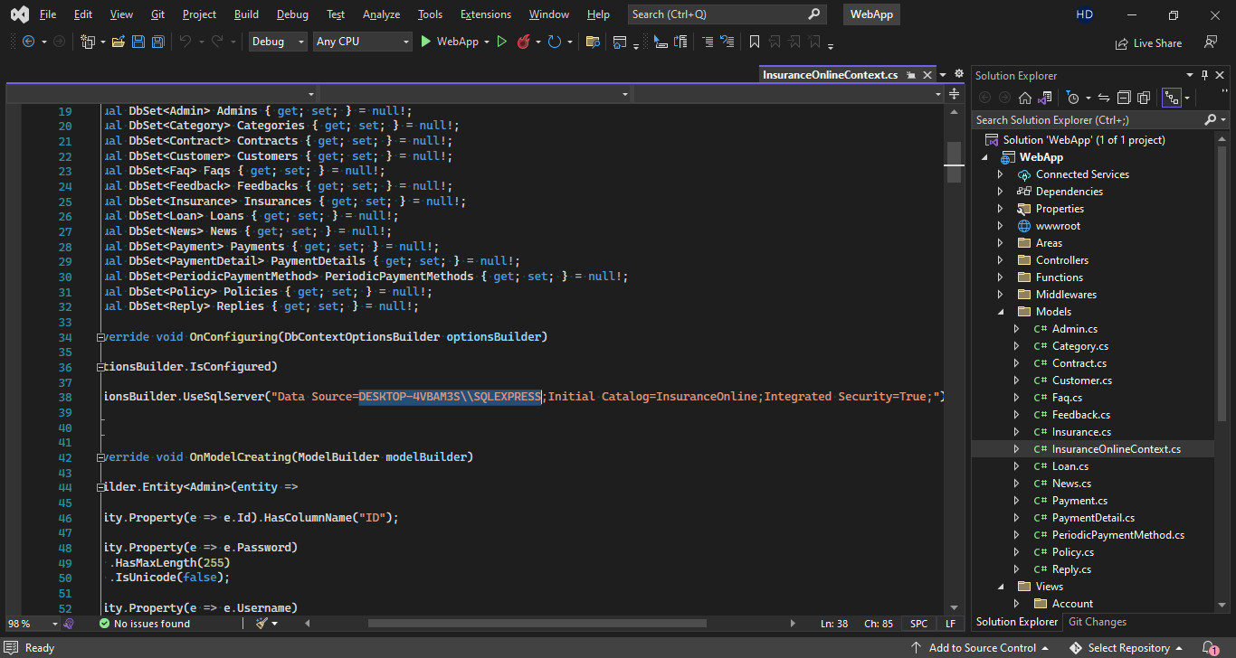

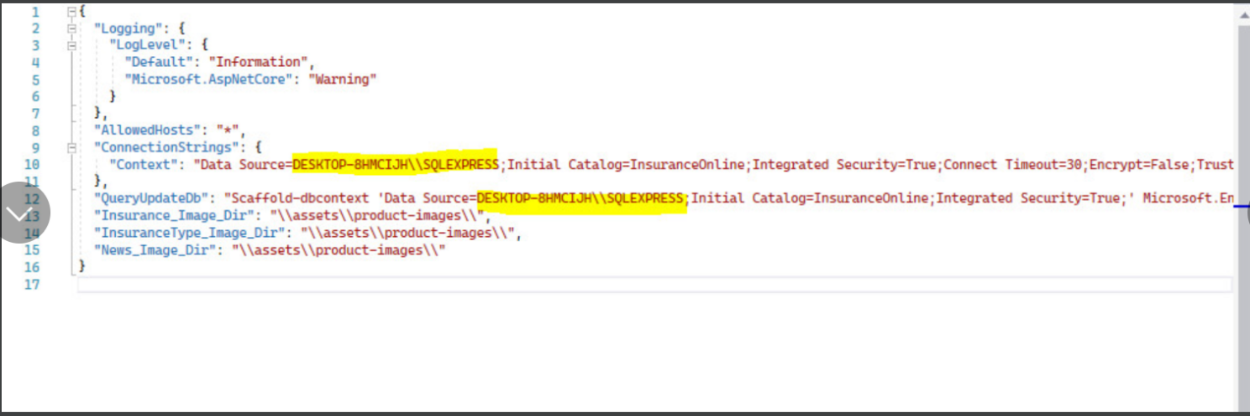

2.4In Microsoft Visual Studio, click on menu Build and select Build Solution

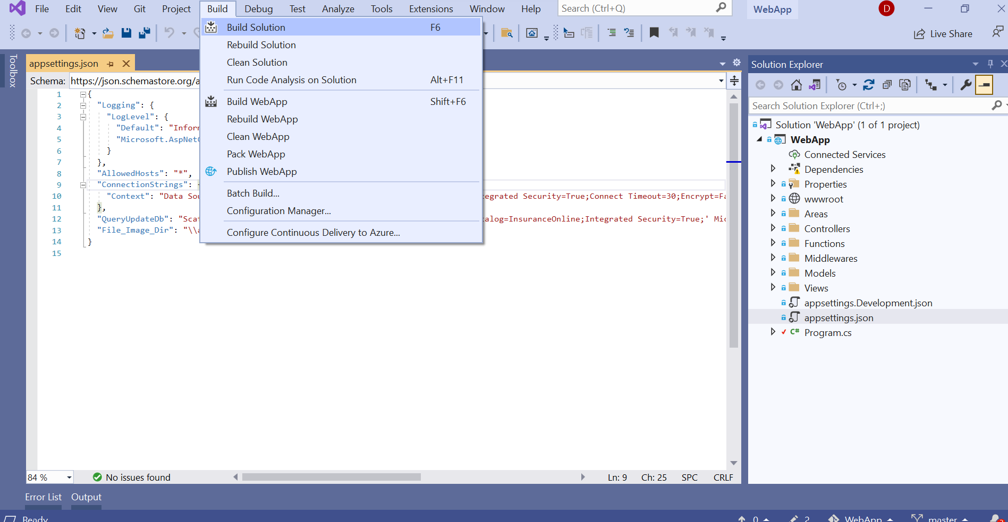

2.5 Click on IIS Express button and the website is ready.

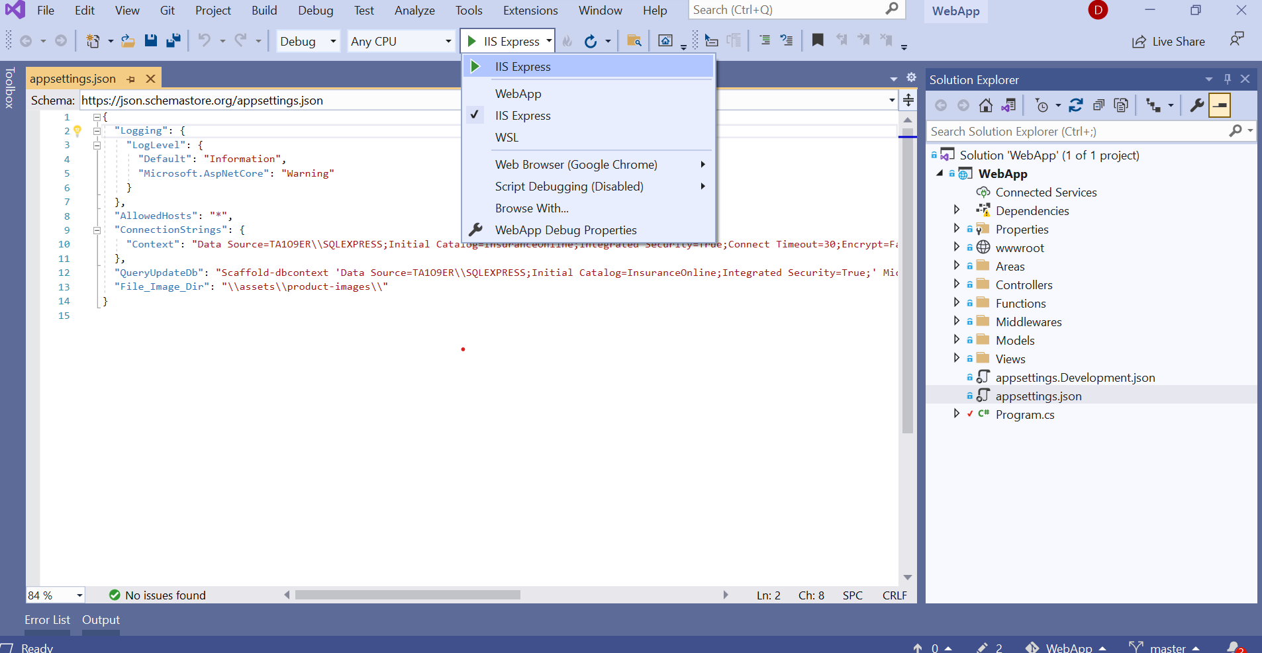

So you have finished the installation of our software. Congratulations on that. We are very honored to be able to guide you, thank you for keeping track!!

*Note: You can use the accounts below to test:*

1. Admin account: admin Password: admin
2. Customer account: [t](mailto:kate@gmail.com)heanh@gmail.com Password: 123

